

Ghulam Ishaq Khan Institute of Engineering Sciences and Technology

Faculty of Computer Science and Engineering

**Hospital Management System**

A Database Management System for Efficient Medical Facilities and Resource Management

**Submitted By:**

Syed Murtaza Salman 2023694 BS Data Science

Muhammad Ashir Siddiqui 2023385 BS Data Science

Salman Shahzad Ali 2023504 BS Data Science

**Under the guidance of:**

Lecturer Abinta Mehmood Mir

Department of CS

Empowering knowledge management through technology

**Table of Contents**

1. Introduction

1.1 Project Overview

1.2 Objectives

2. Business Scenario Analysis

2.1 Scenario Description

2.2 Need for DBMS

3. Database Design

3.1 Entity Relationship Diagram (ERD)

3.2 Design Rationale

4. Relational Database Schema

5. Data Population

6. Querying and Reporting

6.1 Query Examples

6.2 Sample Outputs

7. User Interface

8. Implementation Details

9. Conclusion

10. References

11. Appendices

* 1. Project Overview

This Hospital Management System is a full-stack web application built using Node.js, Express.js, PostgreSQL, and EJS templating. It is designed to efficiently manage hospital data, provide an intuitive interface for patients and staff, and streamline administrative tasks like appointment booking, medicine tracking, and doctor management.

* 1. Objective

The objective of this project is to develop a robust and user-friendly Hospital Management System that digitizes and automates key hospital operations such as user registration, appointment scheduling, doctor and medicine management, and administrative tasks. The system aims to provide a secure and efficient platform where patients can easily book appointments, view available doctors and medicines, and where admins can manage hospital data through a centralized interface. It leverages a PostgreSQL database for structured data storage, and utilizes Node.js with Express for backend logic, ensuring smooth communication between the server and frontend.

2.1 Scenario Description

In a hospital environment, multiple roles such as patients, doctors, and administrative staff interact with various systems for managing appointments, medicines, and personnel records. This project simulates such a real-world hospital scenario by providing an online platform where:

Patients can register themselves, log in securely, view a list of doctors, and book appointments based on availability.

Doctors' data is preloaded by the admin and includes essential information such as specialization, experience, contact details, and profile images.

Admins have dedicated features to manage the system, including adding or deleting doctors, managing medicine stock, and viewing or modifying appointment records.

Medicines are maintained with key details like stock quantity, expiry date, and price, helping simulate an inventory system within the hospital.

The system ensures secure authentication, proper data validation, and separation of concerns for different user roles, simulating a typical hospital's digital operations.

2.2 Need For Database

A DBMS is essential for securely storing and managing hospital data like patients, doctors, appointments, and medicines. It helps prevent data redundancy, ensures accuracy, and allows fast and reliable access to information. In this project, PostgreSQL is used to maintain data integrity, enforce constraints, and handle complex relationships between different entities efficiently.

3. Database Design

3.1 Entity Relationship Diagram (ERD)

The Entity Relationship Diagram (ERD) for the Hospital Management System represents the core entities, their attributes, and relationships. The main entities are:

* Users: Stores user details (ID, Full Name, Email, DoB, Mobile Number, Gender, Occupation, ID Number, Issuance Authority, Role, Address, Password).
* Doctors: Stores doctor details (Doctor ID, Name, Specialization, Experience, Mobile Number, Email, Consultation Fees, Availability, Clinic, Image URL, Description).
* Medicines: Keeps record of medicines (Medicine ID, Image, Name, Price, Stock Quantity, Expiry Data).
* Appointment: Stores appointments (Appointment ID, Patient Name, Patient Email, Doctor Name, Doctor Email, Appointment Date, Created At).
* Admin: Stores admin details (ID, Full Name, Email, DoB, Mobile Number, Gender, Occupation, ID Number, Issuance Authority, Role, Address, Password).

Relationships

* A User can book multiple Appointments
* A Doctor can have multiple Appointments.
* Admins manage records of Doctors and Medicines.
* The system maintains a list of Medicines for hospital inventory purposes.

ERD Description

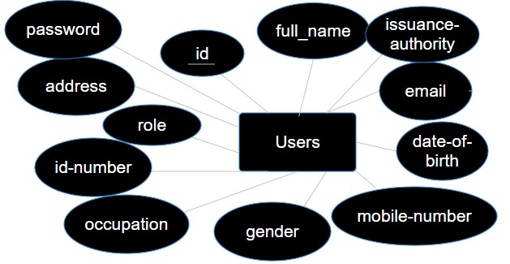 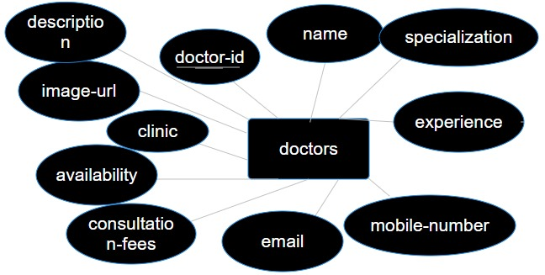

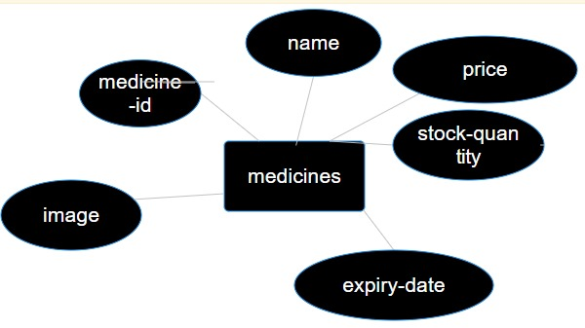 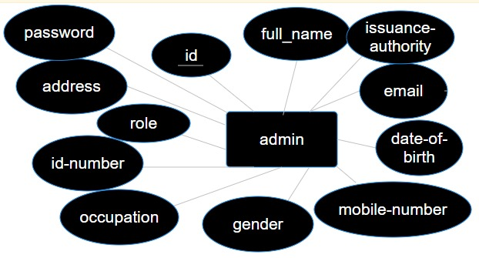

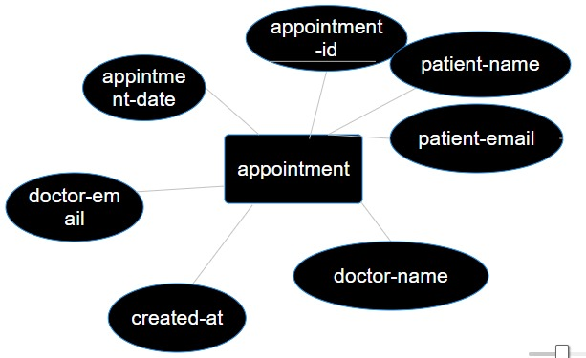

4. Relational Database Schema

|  |  |
| --- | --- |
| Users | |
| Id | Integer |
| Full_name | Varchar(55) |
| Email | Varchar(55) |
| Date_of_birth | Date |
| Mobile_number | Varchar(11) |
| Gender | Varchar(10) |
| Occupation | Varchar(100) |
| Id_number | Varchar(13) |
| Issuance_authority | Varchar(255) |
| Role | Varchar(55) |
| Address | Text |
| Password | Varchar(255) |

|  |  |
| --- | --- |
| Doctors | |
| Doctor_id | Integer |
| Name | Varchar(55) |
| Specialization | Varchar(55) |
| Experience | Integer |
| Mobile_number | Varchar(15) |
| Email | Varchar(55) |
| Consulatation_fees | Numeric(10,2) |
| Availability | Text |
| Clinic | Varchar(55) |
| Image_url | Text |
| Description | Text |

|  |
| --- |
| Medicines |
| Medicine_id | Integer |
| Image | Varchar(55) |
| Name | Varchar(55) |
| Price | Integer |
| Stock_quantity | Integer |
| Expiry_date | date |

|  |  |
| --- | --- |
| Admin | |
| Id | Integer |
| Full_name | Varchar(55) |
| Email | Varchar(55) |
| Date_of_birth | Date |
| Mobile_number | Varchar(11) |
| Gender | Varchar(10) |
| Occupation | Varchar(100) |
| Id_number | Varchar(13) |
| Issuance_authority | Varchar(255) |
| Role | Varchar(55) |
| Address | Text |
| Password | Varchar(255) |

|  |
| --- |
| Appointment |
| Appointment_id | Integer |
| Patient_name | Varchar(55) |
| Patient_email | Varchar(55) |
| Doctor_name | Varchar(55) |
| Doctor_email | Varchar(55) |
| Appointment_date | Date |
| Created_at | date |